Name:

Tutor:

PH30028 – Real solids, surfaces and soft matter physics

COURSEWORK ASSIGNMENT - issued 1 November 2003

Answers to the following question, with this sheet firmly attached as a cover sheet, should be handed in to the box marked “PH30028 -- Real solids, surfaces and soft matter physics” to be found just inside the door of the Undergraduate Physics Laboratory (3W3.19) by 5pm on Thursday 18th December 2003.

Following standard practice in the Department of Physics, work handed in late will lose 20% of all available marks for each 24 hours (or part thereof) past the deadline.

Note that some marks are awarded for presentation. Full marks will be awarded for work which correctly answers the questions, with sketches that are suitable drawn and annotated, and with answers logically structured with a concise explanation of the mathematical steps performed. Marks will be lost for work which just gives intermediate and/or final results, or consists of pages of algebra without explanation.

The marks available for this piece of assessed work are 50% of the total coursework mark for this unit.

Dr N.B. Wilding

3W3.3(b)

tel: x4164
email: N.B.Wilding@bath.ac.uk
URL: http://staff.bath.ac.uk/pysnbw/
(a) A random walk on a cubic lattice is used as a simple model of a polymer chain. The polymer consists of a set of bonds, each represented by a vector r_{i}, parallel to one of the coordinate axes. Write down expressions for the end-to-end vector R, the product R⋅ R and the mean squared end-to-end length ⟨R²⟩.

Assuming that the directions of different bonds are uncorrelated, show that
⟨R²⟩=Nb², where N is the number of bonds and b the bond length or lattice parameter. Demonstrate that this result is correct by direct evaluation for chains of length 1,2 and 3 bonds on a 2-dimensional square lattice.
(It will help if you sketch the possible walks in each case).

(b) The characteristic ratio of a polymer serves as a measure of the stiffness of a chain. It is defined as:
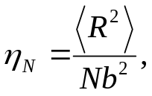

which relates the mean square end-to-end distance 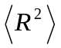, the degree of polymerisation, N, and the length of each bond b. For a freely rotating chain (fixed θ, free φ), use results from your notes to show that
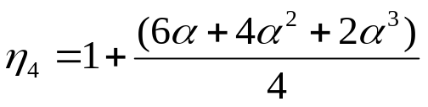

where α=cos(θ ).

(c) Show that a polymer coil typically occupies a volume of space several orders of magnitude greater than the compact volume of its monomers. Also calculate the ratio of the chain’s compact volume to its random walk volume for a chain of 10⁵ monomers with bond length b=10Å and monomer diameter 3Å.

